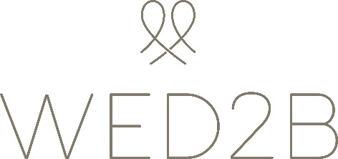

Job Opportunities - Sales Advisors

Fantastic opportunity to help set-up, develop and grow a brand new store in Milton Keynes.
£8 per hour and potential for bonus
At the Wed2b, our mission is to help every bride-to-be who walks through our door to find her perfect wedding dress. We are different to other bridal stores as we sell our designer gowns off-the-peg for a fraction of the price of a bridal boutique.
Responsibilities include;
- Serving customers in a polite, friendly and helpful manner
- Providing advice and guidance on shapes, fabrics and dress fit
- Helping brides into and out of bridal and bridesmaid gowns in a courteous and respectful manner
- Link-selling additional products where appropriate
- Carrying out minor dress cleaning and repairs
- Assisting with deliveries, dress steaming and re-stocking
- Ensuring the shop floor remains presentable and tidy
Previous experience of working with the public in a fashion or similar retail environment is essential and an understanding of shape, fit and fabric is ideal. Experience of the bridal industry is useful but not essential as full training will be given.
You should enjoy working with the public and you will be able to build up rapport and trust with the brides that you are serving. Importantly, you must have plenty of stamina as the role can be fast-paced and physically demanding. The ability to lift dresses and other stock items up to 5kg is essential.

Various working hours available. All roles will require Saturday and Sunday working as a minimum as these are our busiest days.

As the positions require helping brides in a state of undress, for reason of decency, we will only accept applications from female candidates. This role is exempt from the Equality Act 2010.

To apply, please email your covering letter and CV to recruitment@wed2b.co.uk

