SCENE Market Research Results and Analysis

Executive Summary
Almost two thirds of respondents report having been unable to find the right place for their perfect experience (64%), and 93% agree that they would like to be able to find somewhere they were certain to like. Furthermore, a high percentage enjoy visiting new places/events/venues (86%) and are interested in the potential for receiving real-world rewards to use in them (64%). Overwhelmingly, nearly eight in ten respondents think a free mobile phone app offering those services would be useful, interesting or fun (79%), and just over 14% said they would love to use such an app.
However, a majority of respondents are not interested in ranking themselves against others for sociability or receiving social media ‘points’ for attending venues (57% and 79% respectively). Finally, just over 57% of respondents think that they are not that likely to use the app.

Participants
Potential participants were contacted by email containing the relevant information and a link to the survey. Participants were selected on a purposive sampling method, as all were involved with the Science of Social Networks module, share an awareness of social media issues and affordances, and represent a reasonable approximation of the target audience for a new social media application.
47 people clicked through to the survey, of which 14 completed it fully, 11 of whom were men. Participants ranged from 21 to 48 years old. The small sample size means that any findings from this research can not be generalised to the population level as the results are not statistically relevant. Nevertheless, the findings are useful from a market research perspective as they directly inform us about attitudes within the target audience demographic.
Participants displayed wide use of mobile social media, with Facebook, Twitter, Youtube and Whatsapp being commonly used. Participants also expressed most concern over how their personal social media data and social media photographs are used. No participant considered themselves to be in the highest sociability category, however, almost two thirds rated themselves above averagely sociable (63%). This confirms the purposive sampling rationale.

Results
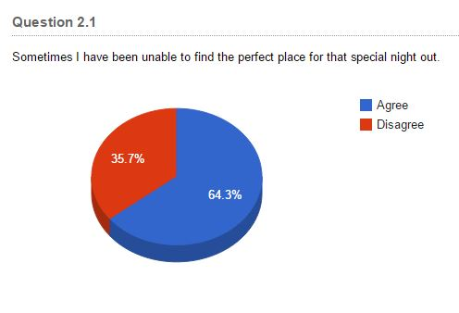

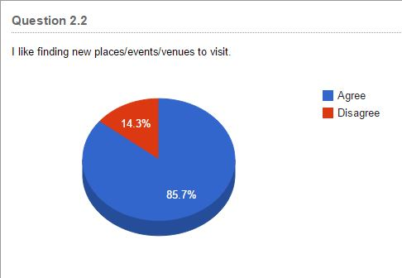
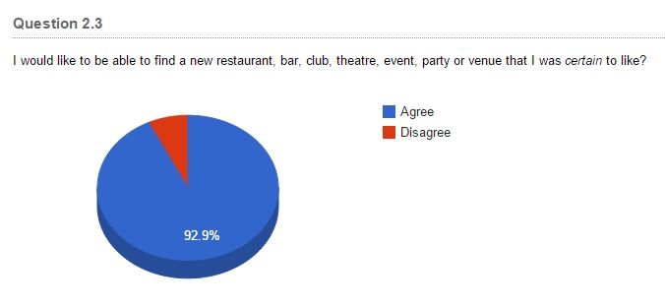

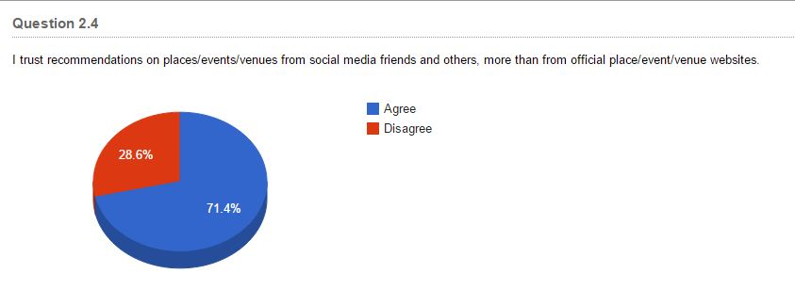

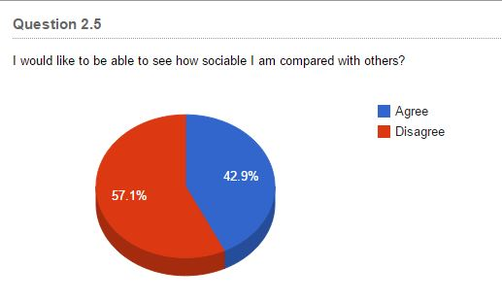

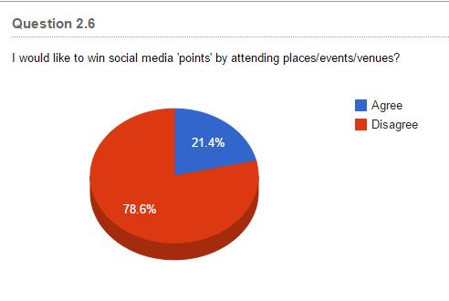

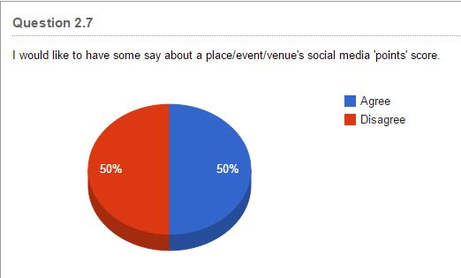

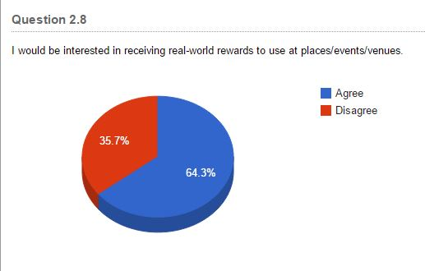

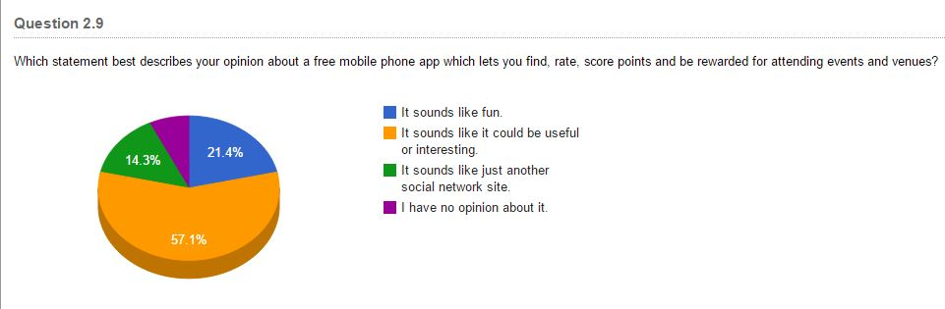

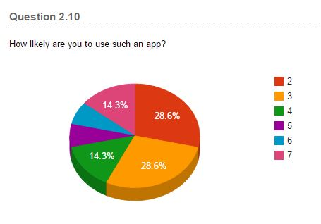
Note: Scale = 1 (Wouldn’t use it) to 7 (Would love to use it)

Analysis
A significant majority of respondents agreed that finding the right place to go for a perfect experience is sometimes difficult (64.3%), that finding new events/places/venues is enjoyable (85.7%), and that being certain to like an e/p/v is highly desirable (92.9%). This suggests that SCENE’s core service – enabling users to locate their ideal e/p/v – would be well received by the market.
Importantly, 71.4% of respondents agreed that recommendations from social media friends (and others) were more trustworthy than officially released information from an e/p/v. Hence the user-influenced SCENE points score for an e/p/v would prove a useful indicator of how fellow peer group members rate that e/p/v and is likely to be more highly trusted than official websites.
Interestingly, less than half of the respondents were interested in ranking themselves against their peers in terms of sociability (42.9%), and fewer than a quarter wanted to win points for attending an e/p/v (21.4%). This apparent lack of interest in the ‘game’ aspect of SCENE may be necessary to take into account in the final design. However, somewhat contradictorily, exactly half the respondents wanted to be able to influence the points score awarded to an e/p/v. This result suggests there may have been a lack of clarity in the questions or a lack of understanding of the ‘game’ concept among the respondents.
Furthermore, a sizeable majority of respondents were interested in receiving real-world rewards to use at e/p/v’s (64.3%). As receiving rewards of different values is intrinsically linked to winning points and gaining levels within SCENE, it is likely that any initial user reservations concerning virtual ‘points’ will be overcome in order to gain better and better real-world rewards in the future.
Finally, and again somewhat contradictorily, although over three quarters of respondents thought that a free social media application providing the functionality proposed by SCENE would be fun or interesting and useful (78.5%), slightly more than half were less than averagely likely to use that app (57.2%). However, half of those who were likely to use the app were very likely or would love to use it (21.4%) and no-one suggested that they wouldn’t use it at all. This suggests that SCENE may be very well received by some and is unlikely to be rejected out of hand by many.

Conclusion
The survey results suggest that SCENE’s core competence of providing a trustworthy, useful, event/place/venue-locating service would be well received. The additional feature of gaining real-world rewards will also prove popular. This should be enough to overcome any suggestion from the results that the gamification features of SCENE were of limited interest and ensure adoption and uptake of the service.

