Participatory Research:
Exploring issues of transfer

Seminar

The Hub Theatre
The Open University
Walton Hall
Milton Keynes
MK7 6AA

April 10th 2014

This is the fourth event in a ESRC funded Seminar Series

Towards equal and active citizenship: pushing the boundaries of participatory research with people with learning disabilities
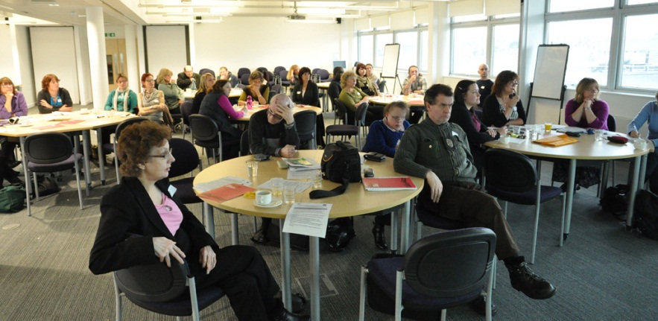
Morning programme

9.30 Tea and coffee and registration
10.00 Welcome

10.10  10.30 | Craig Hart
10.40  11.00 | Learning from extraordinary lives  Sally Holland | 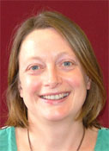
11.10 | Tea and coffee
11.30 | Training away the barriers: mental health service users’, carers’ and academics’ experiences of a research course  Toby Brandon and Caroline Kemp | 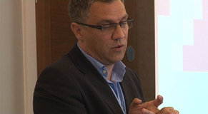  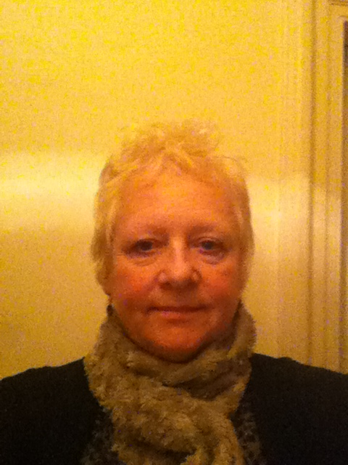
12.00 | Discussion
12.30 | Lunch

Afternoon Programme

1.30  1.50 | Researching together?: reflections on doing participatory research over large distances.  Liz Ellis
2.00  2.20 | “If you could research anything, or see research done into anything, what would it be…”: developing a participatory research relationship with people with dementia.  Sarah Keyes | 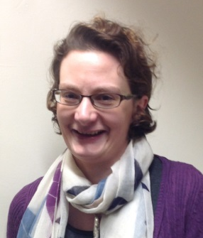
2.30 | More tea and coffee
2.50 | Exchanging notes: Where has inclusive research got to?  Melanie Nind | 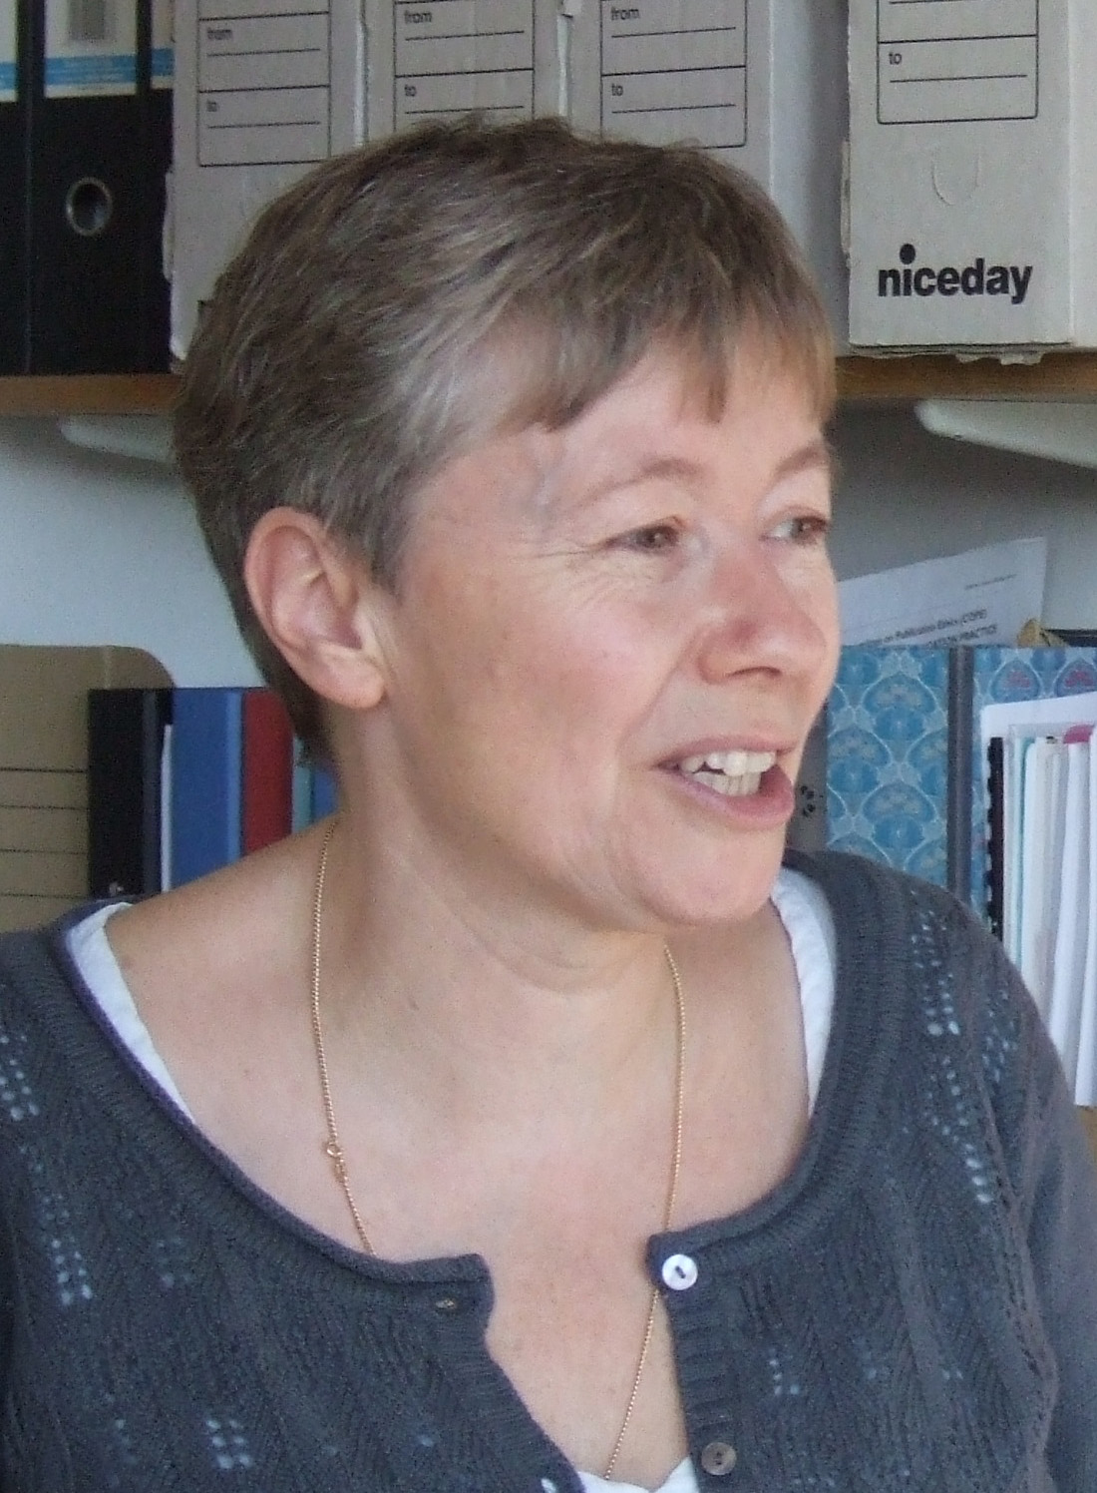
3.20 | Discussion
3.45 | Summing up – what do we want to tell others about the day? | 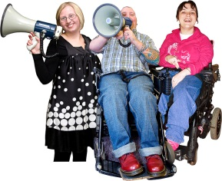
The sessions and the people
Learning from Extraordinary Lives
- This presentation is about involving looked after children and young people in research.
- Children who are looked after usually live in foster care but sometimes they live with family or friends or in a children’s home.
- In this presentation Sally will talk about two different types of participation in research:
- 1) A project called (Extra)ordinary Lives where children and young people chose what they wanted to research about their own lives and how they wanted to do this. They could choose video, photography, diary keeping, interviews and taking researchers for walks on mobile interviews. Young people then got involved in making sense of the research materials and making short films about the findings.
- 2) More recently Sally has been working with care leavers to train them in research methods so that they can provide advice to researchers who want to do research about care or about any other topics to do with young people who need extra help in their lives. They have formed a research advisory group.
- Sally will reflect on lessons learned from these projects, particularly how research is enhanced by participation and also the limitations of participation. She will report on successful ways of teaching research methods to people with a range of educational backgrounds and learning needs – particularly learning through doing.

About Sally
- Sally Holland works at Cardiff University.
- She used to work as a social worker with children and their families.
- Now she teaches student social workers and researches about children and social work.

Training away the barriers: mental health service users’, carers’ and academics’ experiences of a research course

- This presentation is based on a research project funded by the National Institute for Health Research.
- It looks at whether there is a way to mental health recovery through care coordination.
- Mental health service user and carer researchers have told us what is important in the area and decided what to ask people.
- They have interviewed people about their experience of using mental health services, looked at the findings and discussed what they have found at a number of conferences.
- The service users and carers involved had a 10 week training course which prepared them to become researchers for which the University gave a certificate to everyone who attended and a qualification for those who took an examine.
- Research is often done on service users and carers not with them so during the training we all talked about how we could break down barriers between people in the University and the public who use services.
- In this presentation we will talk about how both the people who work at the University and the service user and carer researchers learned together and supported each other during this training and what happened as a result of this course.

About Toby and Caroline
- Toby Brandon completed a PhD at the London School of Economics into empowerment and disability.
- He went on to become a senior researcher at the University of Durham.
- He now works at Northumbria University as a Reader in Mental Health where he is interested in participatory and emancipatory ways of working.
- Toby is also chair of the local charity Disability North.
- Caroline Kemp is a carer working in mental health and recovery at Northumbria University.
- Caroline is also carer rep for the Mental Health Research Network North East and panel member of the National Institute of Health Research.
- Caroline is an active board member of Launchpad, a large service user and carer network in Northumberland, Tyne and Wear.

Researching together?: reflections on doing participatory research over large distances
We are a team of co-researchers living in Cornwall working on a small PhD project using participatory/inclusive research

Our presentation will be about our experiences of doing participatory research on this project and on other projects we have been involved in.

We had some problems doing the research and we will talk about these problems and how we tried to fix them.

Some of the problems were because we all live a long way away from each other. | 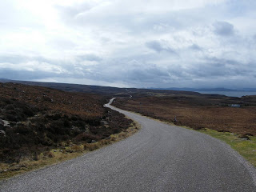
We hope that the answers to our problems will help other people doing participatory research especially in rural areas.

About Liz and colleagues
- Liz is a PhD student at the Open University. She is interested in how people with learning difficulties experience living in the countryside.
- Mark works for Time for Change as a disability awareness trainer. Mark is also involved in community police initiatives and does voluntary work.
- Stuart also works for Time for Change as a trainer and as an admin assistant at a supported employment agency. Stuart also does voluntary work for Disability Cornwall.
- Natasha works for Time for Change as a trainer and an admin assistant. Natasha is involved in her local church community and likes doing arts and crafts.
- John works for Tesco and used to be involved in service user panels for the local college and council. He has recently been working with Janet Bardsley at the Open University contributing to course materials.

“If you could research anything, or see research done into anything, what would it be…”: developing a participatory research relationship with people with dementia.
- In February 2013, I (Sarah) met with a group of people who are living with dementia and asked them “if you could research anything, or see research done into anything, what would that be?”
- We had a lively discussion, which covered four key topics
  - the importance of remaining active;
  - the importance of being part of a group of people with dementia;
  - the importance of changing attitudes towards people with dementia;
  - and lessons for researchers who are working with people with dementia.
- After this meeting, we realised that a lot of work needed to be done to work out the best ways of involving people with dementia in research
- Since then we have been working together to develop “core principles for involving people with dementia in research”.
- The co-created principles cover things like
  - keeping people with dementia involved in research;
  - ensuring that all areas of research are accessible;
  - the importance of ensuring a safe and secure environment;
  - the contrast between “researcher time” (the speed at which researchers work e.g. when submitting a research bid) and “dementia time” (the time and space that people with dementia need when engaging with research); and
  - the need for researchers to be “dementia supporters” (having an approach to working with people with dementia that empowers and enables).
- In this presentation I will outline how the core principles were developed, talk about the principles and explore what the principles mean for the future of research in dementia.

About Sarah
- I am passionate about the role and impact of research in breaking down barriers to inclusion. This includes understanding people’s experiences better, developing better support and challenging stigma and discrimination.
- My undergraduate degree and PhD (both at Northumbria University) were rooted in Disability Studies, and a social model understanding of disability.
- My PhD used an inclusive research approach to exploring peer support by and for people with learning difficulties.
- Since then, I have worked on a range of research projects, many of which have focussed on the experiences of people living with dementia.
- I am also developing a growing interest in the use of creativity, for example theatre, in research.

Exchanging notes: Where has inclusive research got to?

- Melanie will talk about what people who do participatory research have in common.
- She will talk about what they do differently.
- We have achieved a lot so far in changing how we think about and do research.
- This is true of research with and by people with learning disabilities, children and young people and many other groups.
- Melanie will talk about the achievements and also the things we have not managed to do together yet.
- This is based on research she did for her book ‘What is Inclusive Research?’
About Melanie
- Melanie has been doing research for a long time.
- Melanie used to be a teacher.
- Her work is about how we can teach and learn inclusively - and well - and also how we can do research inclusively - and well.
- Melanie works at the University of Southampton

