MARCH 2015 – issue 7 |  | IN THIS ISSUE
What next in ServiceNow?  It is nearly 6 months since we went live with ServiceNow and the system is helping multiple departments to better handle and manage services across the University. Now we are planning the next 6 months, and beyond. To help us with the task, we have created a Service Development Map. This is a visual tool and a guideline for upcoming system implementations. |  | Remedy database –Old tickets available for referencing.  The service development journey –Visual guide for future projects.  Enhancements & improvements  Feature area – ServiceNow in Numbers.  How to… – More hints & tips.
Remedy database  Collaborator: Tim Brody  Old tickets database to be made available for referencing. | We are now firmly and confidently managing services with ServiceNow, so it feels like a long time since we have stopped using Remedy, the old IT service platform. However, being able to access tickets from previous systems can be quite important for a number of reasons - for example acquiring historical information on tickets that can serve as templates for new cases.  You can now search tickets and their attachments from the Remedy system from the following site:  https://www.remedyarchive.soton.ac.uk/tickets/  *A warning message “Your connection is not private” will be displayed. Click the link ‘Advanced’ and from the expanding text, click on “Proceed to srv01145.soton.ac.uk (unsafe)”. Next, you will need to login using your network id and password.  Please note, this service will be available until December 2015. Then the service will be reviewed and a decision will be made as to whether it will be still required or not. See the home page for details on the service capability.
The service development journey  A visual guide for ServiceNow future implementation! | Phase two of the ServiceNow project is now at an advanced stage of planning. All remaining requirements have been identified and structured into workstreams. We have developed the Service Development Map as a standardised way to deliver each of these workstreams.  The Service Development Map has been developed using standard project management practices, but it has also been informed by the challenges encountered in the earlier phase of the project. In addition, as you dig a little deeper into the project plan you see that each map element has in-built activities that meet our working processes: Work Packages, Test Plans, RfC’s, etc.  For all involved in governing the project and those involved in delivering the workstreams, the Service Development Map should act as an accessible way to see what happens and in what order. For example:  - Training resources are engaged from the very start and are involved throughout, and beyond the release.  - Testing and Build resources are also engaged at the same time and fall out of the scoping.  For me as Project Manager, the Service Development Map helps me identify dependencies and also understand where delays could impact the critical path and overall project schedule.
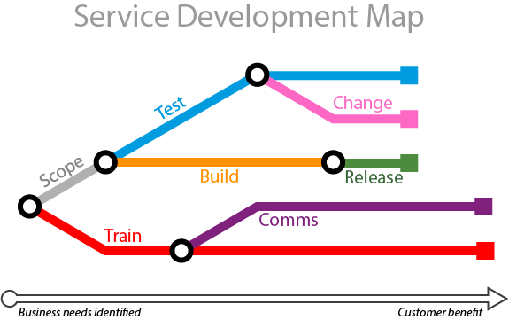
Enhancements & improvements  Due to the patching process mentioned in previous newsletters, larger scale improvement projects have been held until patching is completed. However a number a small scale improvements have been made. | Small scale improvements  There is now a Support Guide link in the user portal.  Separately, the Incident form Email function gets pre-populated with more comprehensive and useful information, such as Full Name, Email Address and User ID.  Change module has also been further enhanced:  - Separate Technical/Peer Approver field  - Added Environment field (Production/ Preproduction/ Development)  - Auto-population of Service Owners and Business Owners for Standard changes has been disabled  Upcoming ServiceNow update  Issues with email notifications will be addressed in the upcoming system update:  - HR emails formatting adjusted to use consistent font, layout and content  - Links to tickets in Customer emails will point at the Portal view of the ticket, not the ITIL (Fulfiller) view  - “No” button renamed to “Re-open” for function clarity  - iSolutions survey link amended to allow for pre-population of ticket details on surveys (more details to follow in the next newsletter)  - P1 and P2 email alerts created  - No ‘Assigned To’ email is sent out when Assignment Group is set to ServiceDesk  - Inactive notifications disabled and active notifications renamed to clean up the list available in the Subscribe view (where notification preferences can be edited)
Feature area: ServiceNow in numbers
Six months on and we thought this was a good moment to find out about ServiceNow volumes, so we decided to put some numbers together. This diagram is a visual approximation of the figures found in the database.
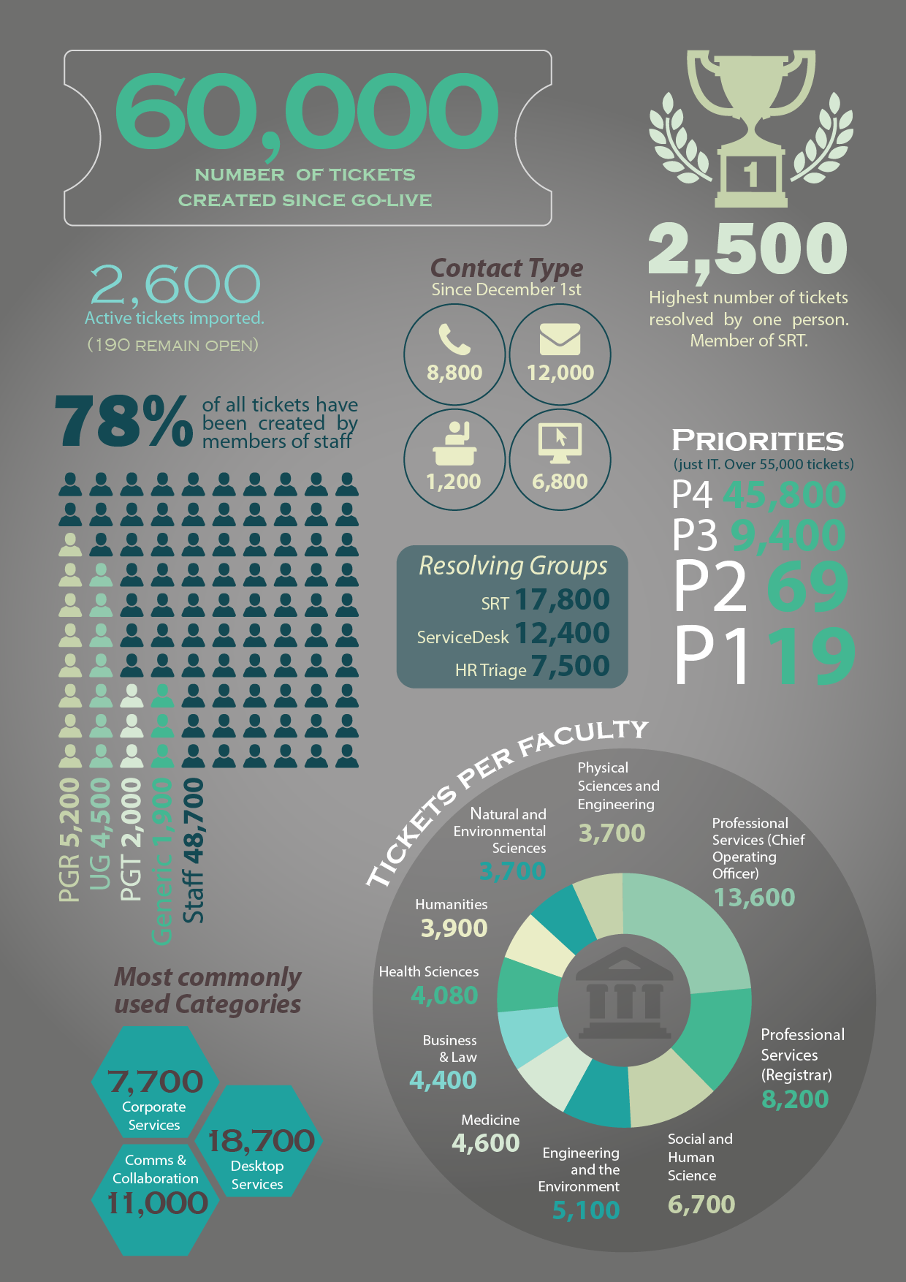

Hints & Tips
In each issue we bring you more suggestions on how to use ServiceNow interface. | How to create tags from a ticket  ‘Tags’ is one of those functions that has a prominent place in the user interface and those who don’t use it may ask why it exists. It is a great way of sorting and categorising groups of tickets. Once the tag is created, tickets can be grouped and later viewed in one place. For example if you need to group tickets that requires visiting the requester: open a ticket and click on the tag icon (1). Type a tag name of your choice(3), or simply click on the already existing tag. To view the tagged group, click the (3) the tag button located on the left hand side panel and the tag label (4). The tickets will display in as “tiles”.  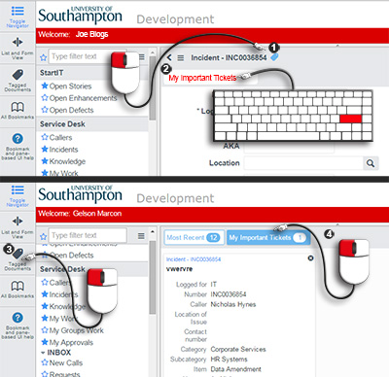
Watch and Work notes Lists
If you wish to receive ticket public notes, it is very easy to add yourself to ticket lists. Once you opened the ticket, simply click on the ‘Add me’ icon (1) and your name replaces the icon. You can also delete your name - First unlock the list (2); then select your name and click on the ‘x’ button (3) to delete it.

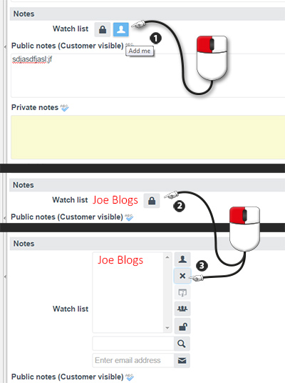

Removing attachment(s)
When an attachment item is added to a ticket, it appears right at the top of the ticket details. Next to the attachment icon there are 2 functions – ‘view’ and ‘rename’; but what about ‘remove’? Although not as obvious, to get to this function you need to click on ‘Manage attachments’ link, or the attachment paperclip icon. A popup opens, where you can select and delete attachment items.

