JANUARY 2015 – issue 5 |  |  |  |  | IN THIS ISSUE
Helping you on your journey!  Newsletter special issue - We are excited to announce that the ServiceNow Support Guide beta version is now available for ServiceNow users. So this issue is entirely dedicated to the guide! We will be discussing how the online guide works, what is currently included and a glimpse of where it will grow in the future. |  |  |  |  | Choosing your route – This guide is dedicated to you  Taking a shortcut – The easy way to search and navigate through the guide  Looking ahead – keep your eye peeled for future enhancements  Mind the gap – We need your feedback to make the guide even better  Tourist information – ServiceNow hints and tips
Choosing  your route  This guide is dedicated to you. |  |  |  | The Support Guide is built around you  When you point your browser to http://go.soton.ac.uk/servicenowsg you will be greeted by a welcoming homepage featuring a collection of avatars, representing different user groups and roles across the University. Clicking on the avatars will take you to dedicated sections, focused on your daily system tasks and needs.  When you find a topic you are interested in, you have two ways of viewing information. The ‘Quick guide’ tab will tell you what to do in a short paragraph or less. However if you would like more details, the ‘Detailed steps’ tab displays both detailed images and step-by-step instructions.  Are you a ServiceLine Online user, or maybe looking to brush up on the dispatcher role?  The Support Guide has been designed with a flexible foundation, and will grow and adapt as the business does. In fact, on the homepage there is a ‘Recent additions’ column so your finger is always one click away from any updates to the guide.
Taking a shortcut  The easy way to search and navigate through the guide. |  |  |  | Being able to navigate the ServiceNow Support Guide is key to your experience. For those learners who need to go directly to a process or task, we’ve included a simple search function. At the top left corner of the Support Guide is the search box – by typing a single word and tapping the magnifying glass, results are pulled from across the site and displayed on the main page. This is useful for those looking to learn on the go.  You will also notice down the left hand column of the home page quick-links to newly added Support Guide content and direct links to ServiceNow and ServiceLine Online. These quick-links to content and other systems will grow alongside the development of the guide, so you can jump directly into the sections which interest you.
Looking  ahead  keep your eyes peeled for  future enhancements! |  |  | We are always seeking out ways to enhance the learner experience, and are beginning to think about how we can develop the content to be more interactive, catering for multiple learning styles.  Some of the potential features coming to the Support Guide could include:  - Embedded videos of system procedures  - Interactive simulations  - Downloadable documents for specific business areas  To begin, we will track the most commonly accessed areas of the Support Guide and identify where the learners are seeking help through focus groups. Watch this space for more information as it becomes available.
Mind the gap
We need your feedback to make the guide even better.

The ServiceNow Support Guide is a growing entity, and we strongly encourage you to get in contact if you have any feedback. It’s currently released as a beta to provide the opportunity for you to give feedback and refine the content.
Is there something you would like to see in the guide, or an amendment? If so, locate the task/process to be reviewed and click on the ‘Feedback’ button. A new email message containing a direct link to the page will open ready for your thoughts. It will go directly to deskside@soton.ac.uk and be picked up by the IT Training and Development team who will then investigate.

Tourist information
In each issue we bring you a few suggestions on different ways to use ServiceNow.

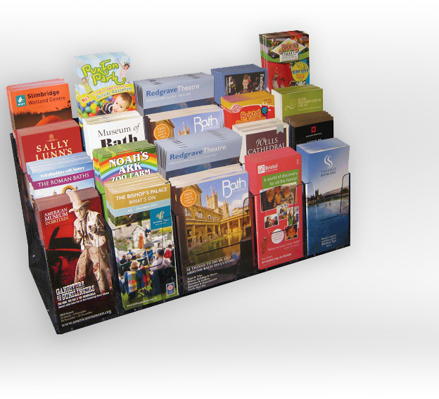 | Filtering with stars  You can quickly filter the main category list in ServiceNow, so only those functions you use are displayed. To see how it works, visit ServiceNow Support Guide and look for ‘stars’ in the top corner.
Viewing multiple tickets is a breeze
If you’re working from a list of tickets, needing to move in and around them, then you can save clicks by having the viewing pane enabled – keep your list on screen as well as the ticket contents! Click here to read how.

Save versus Update
When handling tickets, information needs to be stored for other users to continue to provide a resolution, or ensure all details are up to date. On every ticket you will notice both an ‘Update’ and a ‘Save’ button at the top right hand corner. Read about which to use in the ServiceNow Support Guide dedicated Updates section. This part of the guide will expand over time as improvements to the system take place.

