 |  |  |  | 
JANUARY 2015 – issue 4 |  |  |  | IN THIS ISSUE
Resolutions!  By the time this newsletter goes out, many of us will have made a resolution list. The list is a positive way of starting the year, as it gives us a plan and a desire to achieve. The ServiceNow “resolution list” was created way before the New Year and it is already delivering good results. For example, the platform is impacting positively not only the IT Services, but it is helping the Purchasing and Expenses team in Finance, with their workflow. More about that story below. |  |  |  | Finance and ServiceNow – The benefits of using the system  Superusers – The Support Guide reviewers  Enhancements & Improvements –Reports, Change Module, Mobile and more  External Resources – ServiceNow community knowledge  How to… – More Hints & Tips
ServiceNow in Finance  Collaborator: Vicki Becheley  A brief insight into how ServiceNow is impacting the Finance Department workflow. |  |  | The Finance Purchasing and Expenses team (FPE) is using ServiceNow as a helpdesk system and is already experiencing the benefits - many staff members are now working away from their mailboxes.  Finance is working closely with iSolutions on IT Procurement tickets, where ServiceNow is allowing a better integration between these departments.  The FPE team has been involved in the implementation of ServiceNow from the start, and is currently assisting with requirement gathering and the implementation and planning of Request e-Forms. Once implemented, requests for goods and services, travel and expenses queries will be handled through ServiceNow, allowing Finance to capture all the required information from the outset, ensuring greater efficiency. Once the e-Forms are in place and tested, the plan is to roll them out to the Faculties and PG groups that Finance supports.
“As a team leader, the primary benefit of using ServiceNow is having full visibility of work coming in. It ensures that workloads are evenly spread, with efficient and accurate reporting tasks times. It also allows the rest of the team to assist with IT ticket processing. At the moment, only three members of staff are fully trained to work on ServiceNow, but we will expand the knowledge soon.” Vicki Becheley
Superusers and the Support Guide  Collaborator: James Allen    The ServiceNow Support Guide is currently being reviewed by superusers. This article looks at the role in more detail. |  |  | The term “superusers” which appeared on Issue 3 (December 2014), is a common word used within the computing world, but what does it mean? Are Superusers individuals with special powers?  According to the Oxford English Dictionary, the term is defined as “A user of a computer system with special privileges needed to administer and maintain the system; a system administrator.”  iSolutions superusers have a great level of knowledge and experience within their business areas. They are participating in reviewing the ServiceNow Support Guide, checking the accuracy of the content to help improve step-by-step information, and also provide feedback on the usability of the guide.  We certainly welcome the support from all superusers in Finance, HR and iSolutions, and any other individuals with delegated feedback activities: Patsy Appleton, Vicki Becheley, Mandy Both, Emma Down, Ed Finn, Roger French, Kate Heys, Andie Jenkins, Julie Knight, James Lloyd, Sabine Lucht-Mcquiston, Vicki McQuiston, Alan Nicholas, Debbie Smith, and Russell Smith.  Thank you to all taking part in this vital step; by working in partnership, we can better ensure the quality of the guide.
Enhancements  & Improvements  Collaborator: Apps Management  We are in the first few days of 2015 and we already have a few E&Is to announce, such as the improvements to the Report and Change modules. |  |  | Finance End User Emails  The Service Management team, in collaboration with the Finance team, worked on the redesign of the ServiceNow end users communications. This work has ensured that all emails relating to Finance tickets include the Ticket Number and Short Description, as well as providing a link back to the ticket and relevant contact information. Further enhancements are being made to all email notifications, and these will be coming soon.  Reports  The Reports module has gone through some improvements. Those reports that relate to unused modules and unused areas of ServiceNow (“Out of the Box reports”) have been removed. Secondly, a new set of Global and Departmental reports have been built, in consultation with various business units and stream leads. Further improvements to reporting are planned over the coming weeks.  Mobile  The mobile interface has also undergone some changes. Unwanted items on the navigation menus have been removed. Additionally, fields have been added to various forms, which are based on our personalised ServiceNow configuration. Further improvements are coming, and fulfillers will be called upon to partake in a focus group to generate feedback and ideas on the mobile interface.  Implementation of Change in ServiceNow  With User Acceptance Testing in progress, training on the ServiceNow Change module for all iSolutions staff is planned to start week commencing 19 January 2015, subject to any remedial work and retesting. Each session will last approximately 90 minutes, and will be for up to 20 people at a time. Team Leaders will be sent calendar invites to allocate their staff to one of the 10 sessions being run.  Business Owners and other non-iSolutions staff who act as approvers for Change Requests will be advised of the new approvals procedure via communications from the BRMs.
Feature Area
The University of Southampton is one of many institutions and corporations around the world to have adopted ServiceNow as their IT Service Platform. Using a well-established system has many advantages, such as the level of support and wealth of information that can be found online. In this article we will be exploring some the available external resources.

 |  |  | For Regular Users  ServiceNow has implemented a comprehensive information database developed collaboratively by a community of users - a Wiki-style site. This site provides knowledge to users with different roles and levels of expertise around the world. iSolutions colleagues have found that the site is particularly beneficial for regular users (those who are not Administrators or Developers).  Beginners can find a number of useful introduction articles, as well as best practices ideas. The subjects are presented in different media formats and hence are suitable for a variety of learning styles. Some subject examples:  - A glossary with commonly used terms and acronyms - a useful list, especially for less technically-minded users  - Video tutorials (appearing under the “Get Started” section) showing demos and an introduction to core applications. There are also other videos for Administrators and Developers, such as discussions surrounding automation and monitoring tools  - The site also provides ServiceNow introductory user manuals, which are referred as “Introductory Books”. These can be useful, but do bear in mind that they are generic in nature, and our ServiceNow instance has been customised to suit University requirements  The only downside of the Wiki currently is that many screenshots are now a little out of date as they refer to a previous release of ServiceNow called “Dublin”, as the current version that we operate is known as “Eureka”.  For Developers  The Developers Community is a forum where registered users can post and answer questions, create blogs and make comments. Since ServiceNow can be greatly customised, developers can write scripts to control the system in ways that would not be possible with the standard setup tools. Similar to an Open Source community, the scripts can be made available and shared here. Developers can download, modify and upload their version of the scripts. Additionally, scripts can be rated and sorted in many ways, such as by their voting popularity.  Apart from ServiceNow’s own website, ServiceNow Guru is a blog dedicated to the needs of Administrators, Developers and Consultants. The author of this blog has worked as a Senior ServiceNow Consultant since 2007, and publishes regular solutions to common problems that ServiceNow customers have uncovered over time. He has also developed many ServiceNow solutions that are used by other Consultants and Administrators.
Hints & Tips
In each issue we bring you a few suggestions on different ways to use ServiceNow.
Create an Instant Chart
From a list of records you can create an instant percentage report and display it either as a pie or bar chart. For example, if you wish to see tickets states (‘In progress’, ‘Accepted’, ‘Awaiting 3rd Party’, etc) as a percentage split, simply right click on the “State” column header and select bar or pie chart for an instant report. The function is available for most columns and the result can be exported as a PNG or JPG graphic.

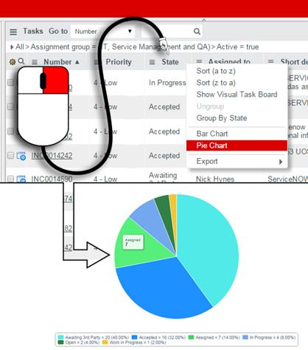
Font Size
Is it difficult to read the data because of the font size? To increase it, simple click the cog symbol that appears on the right top corner (next to “Logout” – the bar colour may be different for you). A pop-up window opens and it lets you adjust some settings, including the font size.

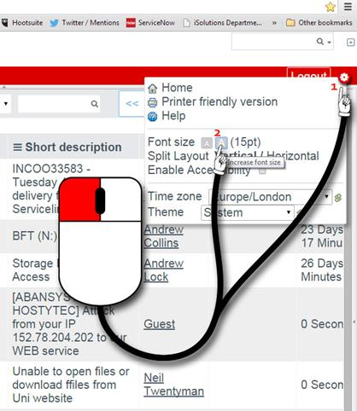
Column Layout
There are many reasons why it can be a good idea to create your own ServiceNow list layouts; it might be because you think there is too much information shown, or not the right data on display. To add or remove columns, click on the little cog, which appears on the left hand side of the column headers. A pop-up window opens displaying two scroll lists ‘Available’ and ‘Selected’. Using the ‘add’ and ‘remove’ buttons, transfer names from one list to another.
By highlighting a line on the right hand side (such as “Location of Issue” shown below), click on the “Up” or “Down” button to move it to a different position in the Selected list. This list, from top to bottom, gives the column order left to right when viewing lists.
Your amended list now shows each time you look at the same screen, and is individual to the way that you work. The cog in the top left will have a small yellow mark within it, if the list is not standard. If you wish to reset the list to its original layout, you have that option from the same screen (to the lower left of the box that is shown in the graphic below, an extra “Reset to Default” option will be shown).
