 |  |   Service  Newsletter  Management  TEam  Team  TEam
NOVEMBER 2014 – issue 2 |  | IN THIS ISSUE
Fixing the Black Hole  We would like to start this week’s issue by saying a big thanks to the ServiceLine team and everyone else who helped with clearing a large number of tickets (1,300 in total) that had resurfaced following the fix of the Permissions Model. All customers have been contacted and ServiceLine workload is no longer impacted by these resurfaced tickets. |  | Portal Usability – A portal improvement based on user’s requirements  Defects List – A new list of fixes  Feature Areas: Testing – The purpose and importance of testing  How to… – Improve your knowledge of ServiceNow functionality
Portal Usability  Collaborator: Peter Gibbs  ServiceNow portal will soon be going through a makeover, but we need feedback from users in order to understand what needs improving. So this is your chance to send us your suggestions! | ServiceNow provides a self-service portal so that customers can log issues, search for help in a knowledgebase, or view their outstanding issues. Thus far the implementation of the portal at Southampton has received a mixed response - most agree it is better than the old system (which required flash player), but there remain a number of concerns about its usability.  iSolutions is working on improving the portal and needs your help to confirm and prioritise functionality and to help test the improved portal when it's ready.  To contribute with ideas and preferences, please join the Service Portal Development groupsite* on:  https://groupsite.soton.ac.uk/Administration/Service-Portal-Development  We'd like to get as much feedback as possible before the Christmas break so that development can be progressed as soon as possible at the start of the New Year.  *Please note that before you can leave feedback, you will first need to apply for a group membership. Simply click on ‘Apply’ button.
Defects  Collaborator: Apps Management  As the hard work to improve the system continues, we present another list of fixed defects. Today’s highlights is that automatic updates will no longer be performed by “Helen Steggall”. | Defects Fixed  - Tickets raised with no ‘Logged For’ which resurfaced following previous Permissions Model fix, have been handled. All affected users were notified and responses created ‘Cloned’ tickets that ServiceDesk managed as a high priority  - Out of Offices replies no longer change the state of tickets. This means that tickets will no longer re-open if an OOO is received  - Assignment Groups no longer automatically get overwritten if the field is already populated - to choose an automatic replacement Assignment Group when changing a CSI, delete the current Assignment Group prior to amending the CSI – this will allow ServiceNow to automatically add the ‘New’ correct Group for you  - An issue was discovered but quickly resolved regarding visibility of Active tickets by end users on the Portal  - The Resolved State is now set as ‘Inactive’, so resolved tickets will no longer show on Active ticket lists and reports  - The automatic Close period has been extended from one day to five days (three working days plus two to accommodate weekends) – this will give longer for end users to respond if their issue is still outstanding without creating a new ticket  - Automatic updates to tickets are no longer performed under the name “Helen Steggall”. They are now set against “ServiceNow”. Some of these updates have also been reworded for clarity
Feature Areas
Collaborator: Valerie Thornton

Our feature area of this week is Testing. Testing can serve many purposes - it can provide information on a system, it can give confidence to end users or it can identify issues prior to go-live.

Testing can help provide a level of confidence that changes made, or resolved issues in ServiceNow won’t cause defects elsewhere. | The focus of system testing is the verification of the system against baseline requirements, executing the code and ensuring it meets the behaviour requested by end-users. This differs from User Acceptance Testing, which aims to validate the requirements against the actual need of the end-users. Testing can help provide a level of confidence that changes made to ServiceNow have given new functionality, or resolved issues without causing defects elsewhere.  Issues Encountered  - Comprehensive system testing was not completed before the launch of ServiceNow. A consequence of this is that over 100 defects have been identified in UAT (User Acceptance Testing) and contributed to the post go-live issues felt by users  - Comprehensive system testing provides the basis for regression testing. The purpose of regression testing is to confirm that a change or defect fix has not resulted in new defects  - One of the key learning points from Phase 1 of the project was that comprehensive testing must be completed before a change or defect fix is promoted into the live environment  Current Tests  We are currently reviewing and determining an appropriate amount of testing on ServiceNow defect fixes, focussing on areas which include: a) changes having a major impact on business; b) complex areas; c) areas with previous major defects. As well, new project deliverables are being system tested prior to UAT, to ensure that we have high levels of confidence in the area prior to go-live.
Hints & Tips
In each issue we bring you a few suggestions on different ways to use ServiceNow.

Information Pop-ups – Have you ever noticed the pop-up icons that appear next to certain fields? If you hover the cursor over the icon, it shows a snapshot of information, but as soon as you move the cursor away the pop-up disappears. This is OK if you are only reading, but sometimes it is useful to copy information too (so you can paste somewhere else). To keep the pop-up open, first hover over the icon and then press the ‘shift’ key on your keyboard. You will notice that an ‘X’ icon is added to the pop-up window, which lets you close the window.
 | ServiceLine Online keeps a history of all the Incidents and Requests you’ve logged. Click on https://sotonproduction.service-now.com/soton/ and choose ‘All my issues’ and ‘All my requests’ to see them. It will also tell you what is currently open or closed and you can click on an item to update it, or just find out the current progress. A one-stop shop for all the activity on your issues.
Do you want instant access to your most frequently used filters? Just use ServiceNow Bookmarks! ServiceNow Bookmarks appear on the left side bar and give you instant access to filters.
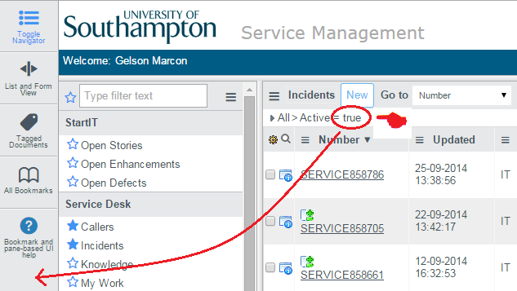
It is very simple to setup: 1) once you create a filter, “grab” the filter by clicking and holding at the end of the string (located at the top of the tickets list, above the labels); 2) drag all the way to the side bar and release; 3)an icon will be added to the bar. The icon picture, colour and name can be customised by hovering over the bookmark, and clicking on the ‘Edit Bookmark’ in the pop-up that displays.

