Standard Error

Introduction

The standard error is a good test to use when you are looking at:
- Differences between the same variable in different samples
- If you wish to find out whether there is a significant difference between the means of different samples
- The size of each sample set is at least 30 measurements (smaller sample size requires a variation on the equations)
Calculating the standard error can help you to decide whether there is a difference between the means of two sets of measurements. When you take a sample and calculate the mean, it is important to remember that this is only an estimate of the true mean for the population you are measuring. If you took a second sample, you would probably arrive at a slightly different estimate of the mean. The standard error allows us to estimate the range within which the true mean for the whole population is likely to lie.
There is a 95% chance that the true mean lies within two standard errors either side of the mean of your sample.
For example: If a calculated mean limpet size for an area on a shore is 54mm and the standard error is 1mm, then there is a 95% chance that the true mean size for the whole population is between 52mm and 56mm (54-2 = 52mm and 54+2 = 56mm).
Say limpet size is measured again in a different area and has a mean of 46mm with a standard error of 1.5mm. In this case we can be 95% certain that the true mean lies between 43mm and 49mm (46-3 = 43mm and 46+3 = 49mm).

How to interpret the results
Looking at the two means in the previous example, it looks as if there is a difference in the size of limpets at the two places. However, looking at the mean alone does not tell you how likely it is that the difference you have found is due to chance. This is where the standard error comes in. The standard error not only compares the means of two sets of data, but the ranges in which the true mean can lie either side of it.
Once you have calculated the standard error (see how to calculate it below), you interpret the result by looking for any overlap between the possible ranges for the means.
For instance: In the previous example, the highest possible value of the mean for the second population (49mm) is lower than the lowest possible value for the first population (52mm). There is no overlap between the possible ranges for the means. We can therefore say with 95% confidence that there is a real difference between the means of these two populations.
- The difference is not due to chance.
Alternatively, we could have exactly the same mean figures for the two populations, but a larger standard error would lead us to a different conclusion.
For example: If the standard error for the first sample in the above example was 1.5mm instead of 1mm and the standard error for the second sample was 3.5mm instead of 1.5mm, then the ranges within which the true mean would lie for each would be 51mm-57mm (54-3 = 51mm to 54+3 = 57mm) and 39mm-53mm (46-7 = 39mm to 46+7 = 53mm). The ranges of these means now overlap: The highest figure from the second population (53mm) is greater than lowest figure from the first (51mm). We cannot, therefore, be confident at the 95% level that the means of these two populations are really different
- The difference could be due to chance.
The larger the standard error, the larger the possible range in which the true mean can lie and the increased possibility of overlap between the two ranges of different sets of data.
It is common to represent this visually by drawing a bar chart showing the means of the two samples, with error bars showing a range of two standard errors either side of the mean (see graph in worked example below). It is then possible to see whether there is any overlap between the error bars from the two samples.

How to calculate standard error
For those uncomfortable with maths, here is an explanation in words before coming on to the formulae.
Step 1. Calculate the mean of your sample. This is the sum of all the measurements divided by
the number of measurements.
Step 2. Calculate the standard deviation of your sample. To do this, calculate the difference between each individual measurement and the sample mean. Square each of these figures. Add the
resulting figures. Divide this figure by the sample size minus 1. Find the square root.
Step 3. Calculate the standard error. Do this by dividing the standard deviation by the square root of
the sample size.
Step 4. Plot a bar graph of the two means with ± 2 S.E.
Here is the same process expressed as mathematical formulae, and a worked example for you to follow.
Step 1. Calculate the mean: Mean = ∑x
n
Step 2. Calculate the standard deviation: s = √ (∑ (x -mean )²)
n - 1
Step 3. Calculate the standard error: S.E. = s
√n
(Where: ∑ = Sum of, x = samples, n = number of samples)

Example
Is the size of limpets significantly different between the upper and middle ledges at Bembridge rocky shore?
(Sizes in mm, measured using callipers)
Middle: 43.9, 38.4, 39.4, 44.7, 40.3, 37.8, 35.6, 56.7, 47.3, 36.0, 38.7, 37.7, 41.6, 42.5, 48.3, 34.9, 21.3, 42.5, 36.2, 46.8, 41.6, 43.5, 48.6, 39.5, 50.2, 46.9, 48.7, 42.9, 37.6, 53.4
Upper: 40.3, 35.0, 36.2, 40.8, 31.2, 30.2, 27.3, 37.7, 26.5, 25.5, 33.6, 24.8, 42.3, 38.6, 30.7, 23.2, 37.3, 34.6, 32.3, 33.0, 34.6, 38.0, 28.3, 22.5, 37.0, 45.0, 32.8, 36.9, 44.2, 28.6
Step 1. Mean
Middle = 1263.5/30 = 42.12
Upper = 1009.0/30 = 33.63
Step 2. Standard Deviation
Middle = √1391.207/(30-1) = √47.973 = 6.736
Upper = √1078.801/(30-1) = √37.200 = 6.071
Step 3. Standard Error
Middle = 6.736/√30 = 1.230
Upper = 6.071/√30 = 1.108
Step 4. Bar chart of the two means with ± 2 S.E.
Middle= 42.12 ± 2.46 mm
Upper = 33.63 ± 2.22 mm
No overlap between the error bars on the bar chart shows there is no overlap at the 95% confidence limits (see below)
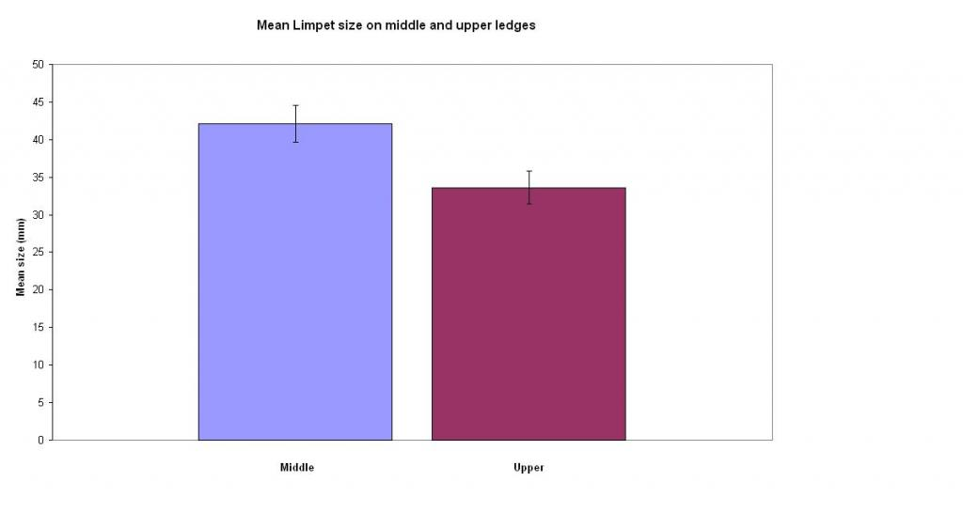
- We can therefore reject the null hypothesis. The maximum mean on the upper ledge could be 35.813mm and minimum mean on the middle ledge could be 39.641mm, therefore no overlap and they are significantly different sizes:
- There is a significant difference in the size of limpets between the middle and upper ledge at Bembridge. Limpets found on the middle ledge being significantly larger than those on the upper ledge.

