*JESI 2014*

*During my Italian field trip to Jesi I had the opportunity of hands-on experiences and observing authentic Italian daily life. From my observations I developed an interest in churches and the role they play in Italian daily life.*

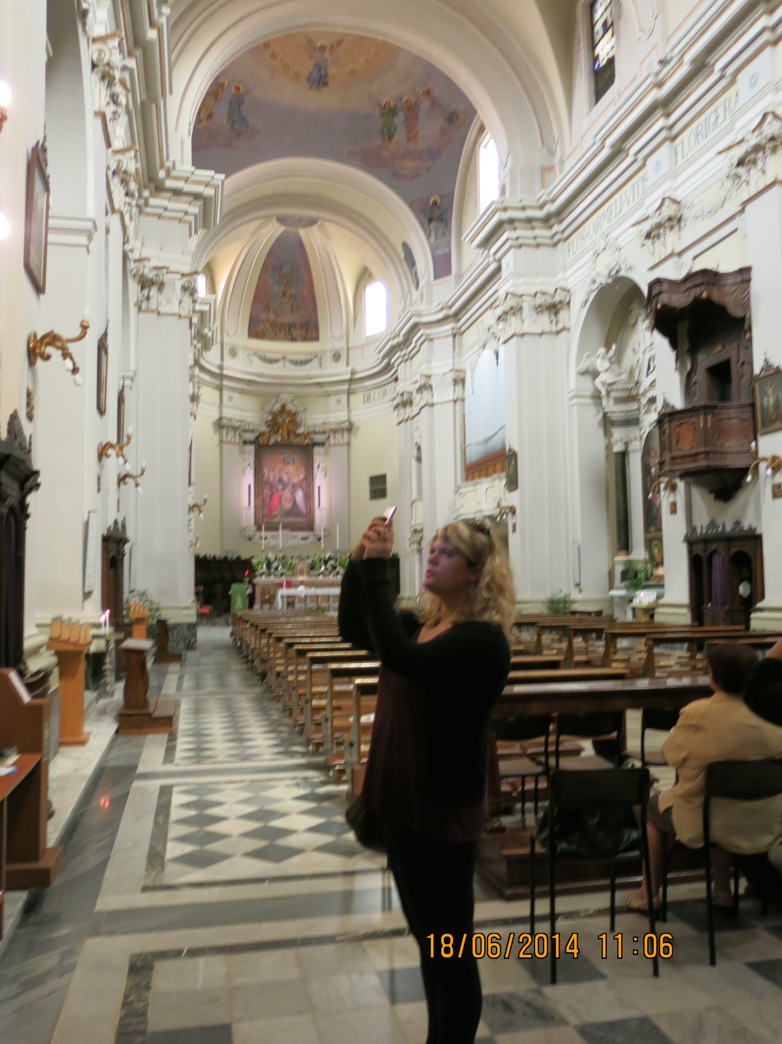

*In general, all of the churches that we visited in Jesi were very ornate and richly decorated. Almost every single surface and space was gilded or carved.  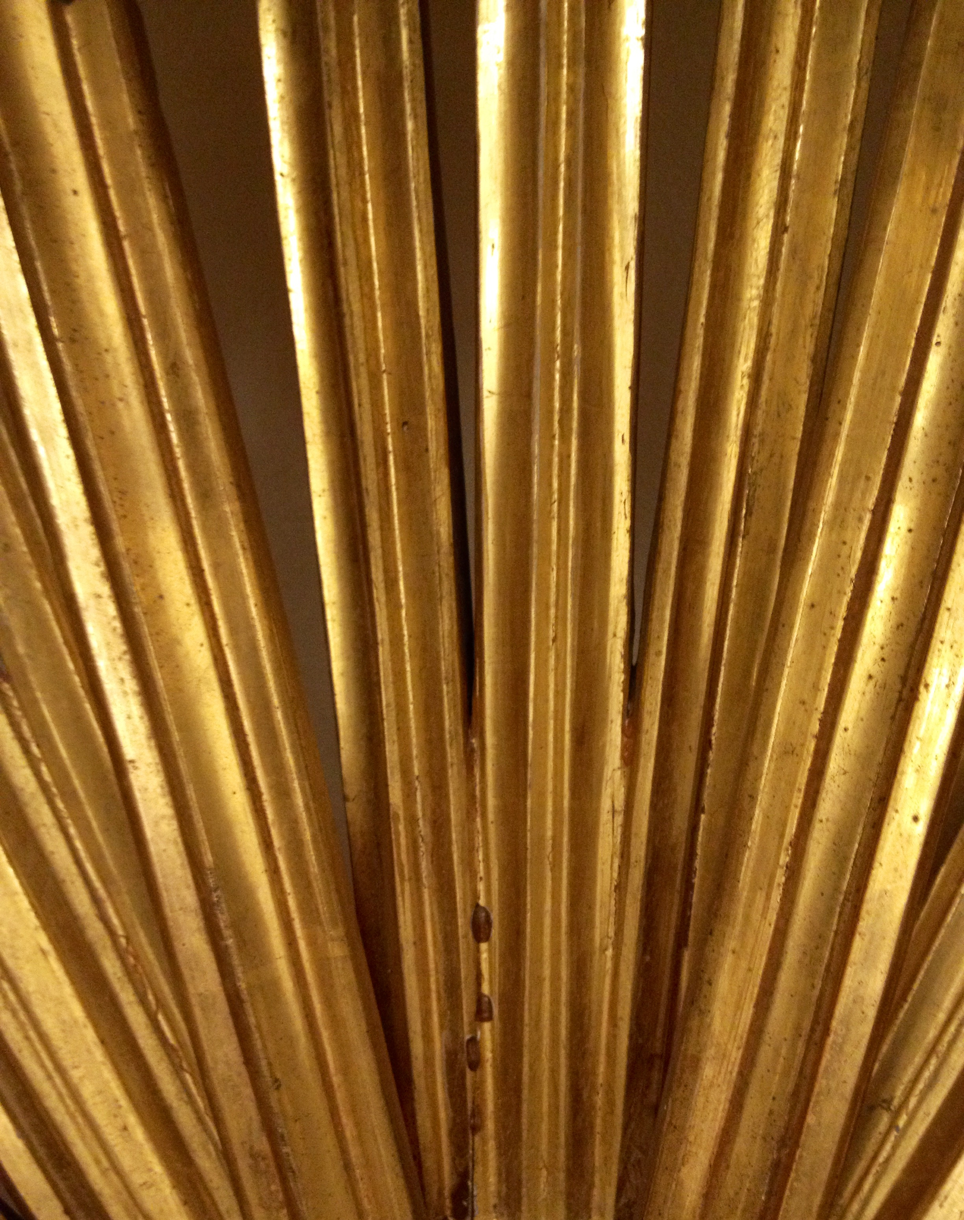 A detail from a wooden frame in a church (Courtesy of Sophie Major, all right reserved)*

*There were the very obvious differences between the Catholic Churches in Italy and the Anglican Churches in England, such as the confessionals and the focus on Saints.*

*However, what I found more interesting was the slightly more subtle fact that the Churches seemed to be a really important part of the everyday life. In particular the number of churches, the very public mass celebration we witnessed in the centre of the town, and how many people were praying or visiting the churches during the day, all suggest that they play a very important role and I this is something I would like to investigate further.*

**Suor Cristina… La suora più famosa d’Italia?**

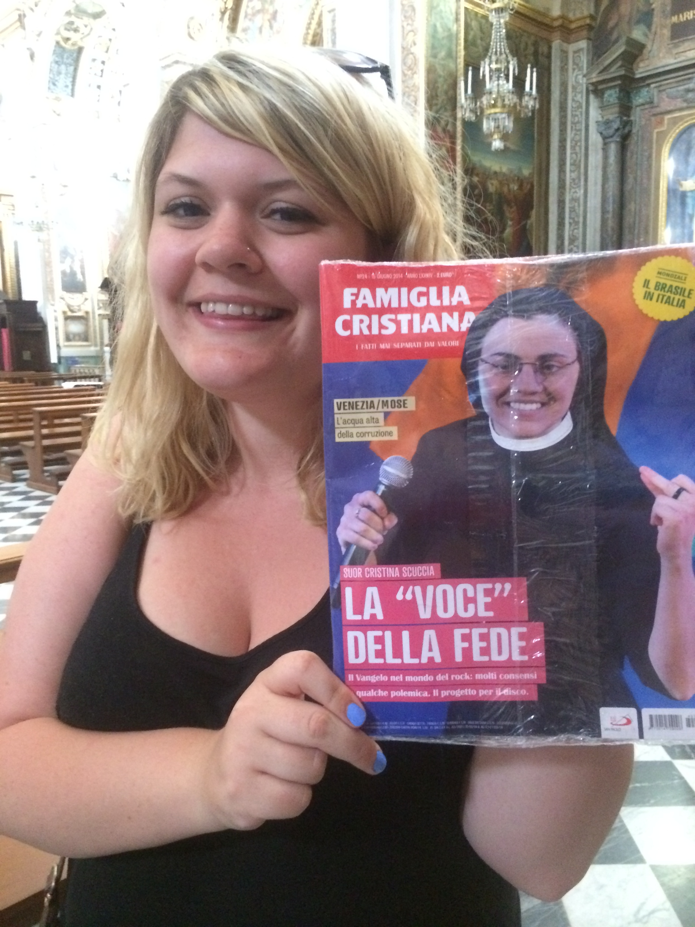 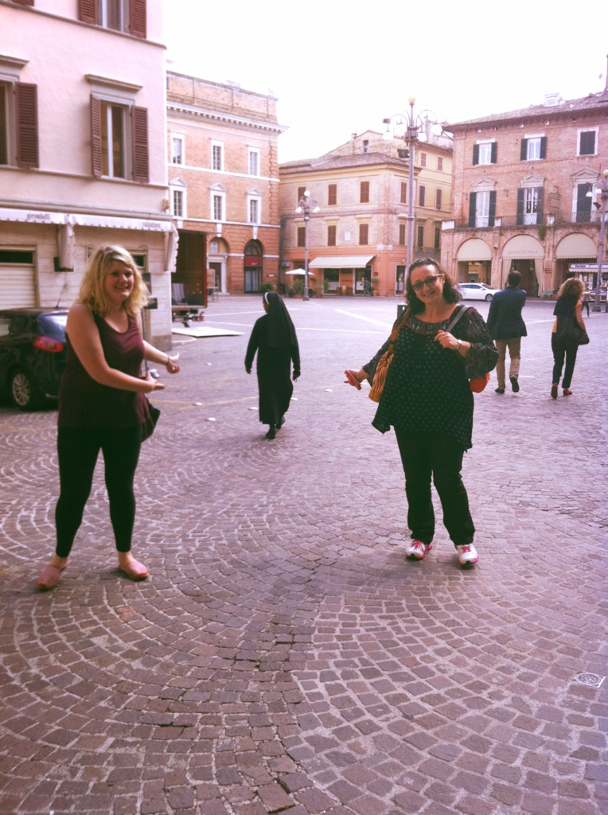

*While studying Italian we came across a “unique” phenomenon, which was popular on Italian X Factor: Suor Cristina (above: me and a magazine featuring the most popular nun in Italy who eventually won X Factor 2013).*

*I would like to know more about the life of nuns in Italy... In England, I feel it is fair to say that you very rarely see nuns walking around towns or cities. I found it fascinating that we saw a comparatively high number of nuns in Jesi, which suggests it is more common in Italy. I would be really interested to learn more in the future about what motivates young Italian women to join convents, how actively they contribute to society, and how common is it actually to find nuns in Italy.*

*Imogen Hambly*

*University of Southampton*