My experiences in “Italia”

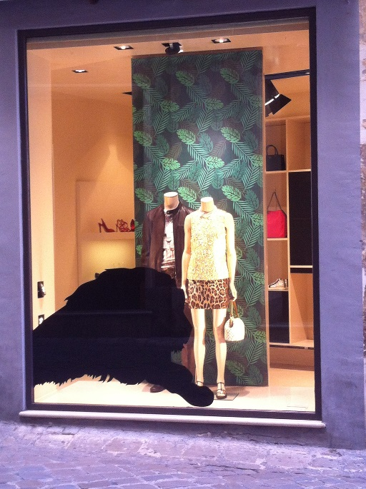Mamma mia, what a memorable week we’ve had! From day one we all saw and experienced new things that il Bel Paese had to offer.

Firstly, Jesi, the beautiful chic town we stayed in was bigger than I expected; there were a lot more monuments and spacious *piazze* to explore – plenty of shops and bars too! The fashion there was incredibly striking. I was mesmerised by women and men’s taste in clothes and elegant colour combinations as well as jewellery. Almost every woman carried a designer handbag with them and wore very flattering shoes wherever they went; high heels, smart pumps, boots or colourful sandals. I realised that the ‘bella figura’ was highly important in a small town like Jesi, and looking unfashionable and boring wasn’t an option for the locals! In the evenings, people brought jumpers wrapped over their shoulders and neck in case the weather got colder. I rarely see this habit in England, usually the British either wear a jumper or bring jackets. Because Jesi isn’t an exceptionally big place, everyone knew each other well. So when we strolled around the town, all eyes were on us! The look on people’s faces said it all: “who are these foreigners?” Some people smiled, others just stared. But the elderly men at the bars every morning were charming and made an effort to speak to us!

Secondly, I adored the Italian cuisine. As everyone knows, pizza and pasta is always on the menu in Italy, but I fell in love with *“la piadina”* a savoury wrap with melted cheese and Parma ham I had never tasted until last week! I also made the most of the exquisite seafood, it was so fresh and tasty.

Beverage-wise, *la cedrata*, a fizzy, refreshing lime green drink turned out to be very popular in the group, once we’d tasted it, we ordered it in every restaurant we dined in.

But, for me, it was all about the espresso! It was so rich and smooth, not at all like the one from COSTA! I admired the way the Italians drank their morning coffees standing at the bar and chatting – over here we usually sit down at a table.

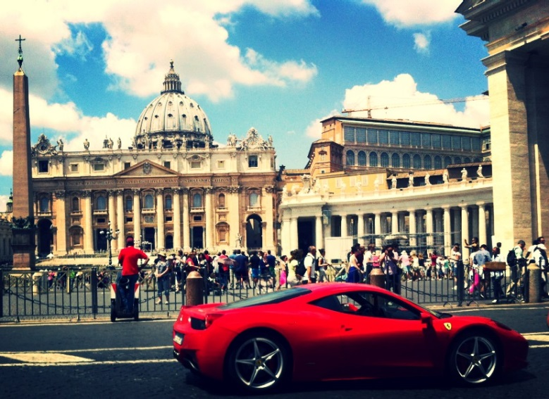The way of living over there was just as I expected it to be; going out late at night, loud voices, old men sat in benches people-watching, and siesta time between 1 – 4p.m. to avoid the scorching weather. However, I was very surprised at the punctuality of public transport! There are certain stereotypes that say Italians never arrive on time, however our train to Rome was very prompt and arrived at the platform at 06:56 a.m. as it said on our ticket. It must have been a sign of luck, as our day out in the Italian capital was a great success and none of our belongings were robbed! We also spotted glamorous Ferraris (so much for the country’s economic crisis), in the capital near the Vatican which made an incredible photo!

However, I didn’t know that there would be so many beggars! They constantly begged for money wherever you went and often got a bit frustrating and aggressive when you tried to avoid them.

All in all however, we were all charmed by the Italians’ open personalities. In restaurants, nearly every waiter that served us complimented us on our Italian and how well we spoke it. The compliments made by male waiters were aimed at us girls, of course – Italian flirts!

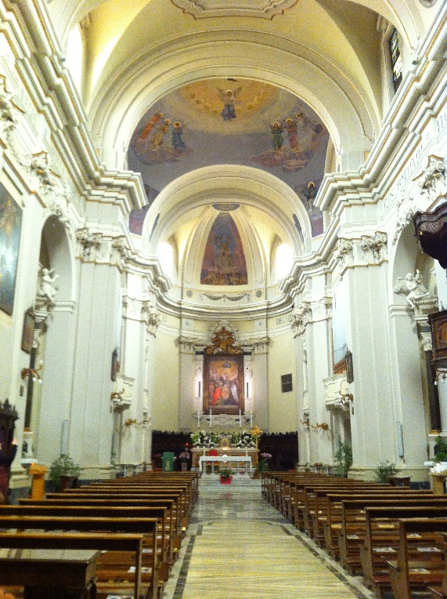

Another amusing aspect I love about the Italians is their hand gestures and body language when they speak. They really emphasize every phrase by putting the tip of their fingers together, shake their hand and say “mamma mia” or “che ne so!” We visited churches nearly every day and were astounded by their architectural beauty. Many of them were constructed in Roman, Gothic and Baroc styles. My personal favourite was Roman style, as it told so much history of the once-Latin country.

All in all, we enjoyed ourselves immensely. We were able to practice our Italian language a lot with locals, shop keepers and our fabulous teacher. We took plenty of photos of the gorgeous countryside, absorbed the pleasant sunshine and feasted on countless gelato flavours everyday – I loved ‘bacio con frutti di bosco’, buonissimo!

By: Carla Ringand Mendez,

University of Southampton

02/07/2014