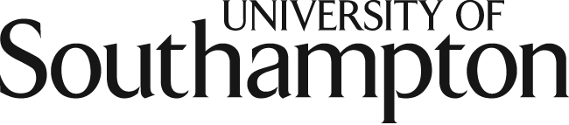

Institute for Language and Culture (http://blog.soton.ac.uk/ilc/)

‘New Directions for Research in Language and Culture’

Wednesday 6 November 2013

University of Southampton, Avenue Campus, Building 65, Lecture Theatre A

The Institute for Language and Culture (ILC) at the University of Southampton is holding a one-day symposium on 6 November 2013 to explore ‘New Directions for Research in Language and Culture’. The event will include keynote presentations by external speakers, the inaugural lecture of Professor Marion Demossier, an engaging discussion and debate about the future of language and culture research, and opportunities to hear about current research at the ILC. Confirmed speakers include: Professor Charles Forsdick, University of Liverpool and AHRC Translating Cultures Theme Fellow; Professor Andrew Higson, University of York; and Professor Susanne Ehrenreich, University of Dortmund.

Programme

10:00 – 10:15
Welcome and introduction to the day (Professor Anne Curry, Professor Michael Kelly)

10:15 - 11:00
Keynote speaker: Professor Charles Forsdick, University of Liverpool and AHRC Translating Cultures Theme Fellow
Chair: Professor Mary Orr

11:00 – 11:30
Postgraduate poster session with coffee

11:30 - 12:15
Keynote speaker: Professor Andrew Higson, University of York
Chair: Professor Lucy Mazdon

12:15 – 13:30 Buffet Lunch, North Corridor

13:30 – 14:15
Keynote speaker: Professor Susanne Ehrenreich, University of Dortmund
Chair: Professor Jennifer Jenkins

14:15 – 14:30
Coffee break

14:30 – 17:00
Future Directions in Language and Culture Research: the Big Debates

17:30 – 18:00
Refreshments before inaugural lecture

18:00 – 19:00
Inaugural lecture of Professor Marion Demossier

19:00-20:00
Drinks following inaugural lecture

