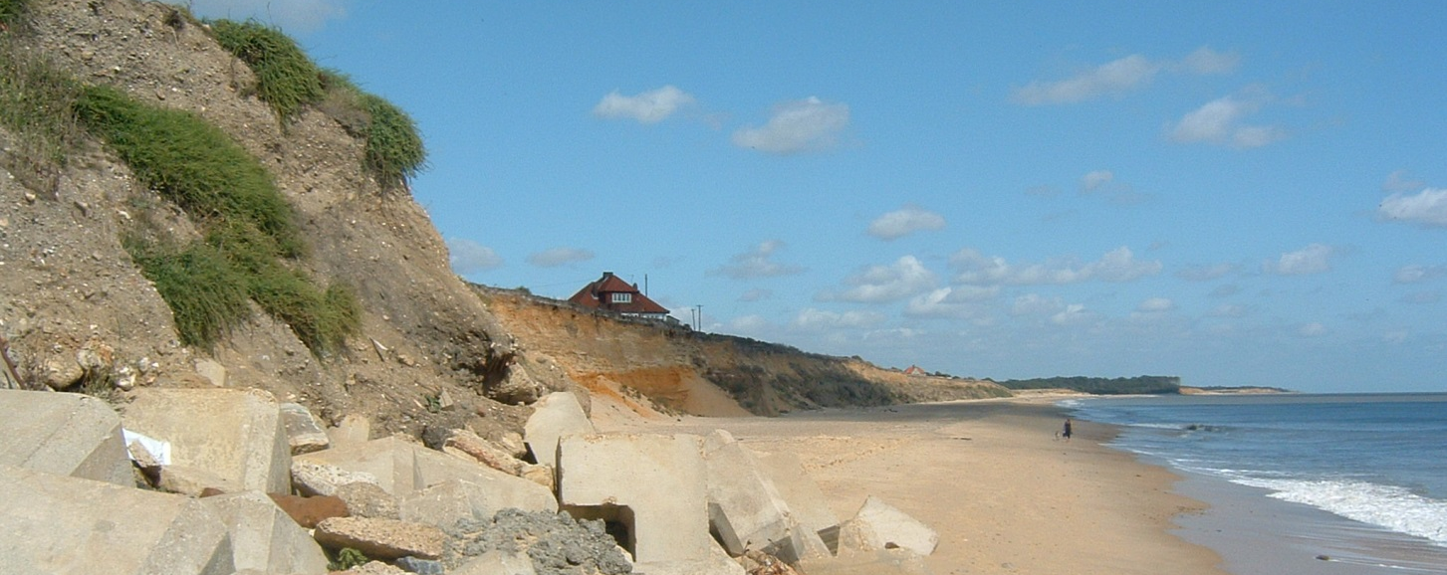
Coastal Seminar Series, Semester 1, 2013-2014

Monday 21 October at 12.30 Prof. Efi Foufoula-Georgiou (University of Minnesota), “Dynamic Building 34/3001 connectivity as a metric for resilience in river network processes”

Monday 4 November at 12.30 Dr. Paolo Cipollini (National Oceanography Centre), “Satellite Building 67/1003 altimetry in the coastal zone: past, present and future”

Thursday 14 November at 15.30 Dr. Valentin Heller (Imperial College London), “A hybrid
Building 32/3077 investigation of the effect of the water body geometry on landslide-tsunamis”

Monday 18 November at 12.30 Dr. Andres Payo (University of Oxford), “Erosion and accretion Building 34/2003 along part of the Suffolk coast of East Anglia: a review of process understanding”

Thursday 28 November at 15.30 Alanoud Al-Ragum (University of Southampton), “Sand transport
Building 07/3023 in the Oka estuary (Urdaibai Biosphere Reserve, Spain)”

Thursday 28 November at 18.00 Prof. Richard Tol (University of Sussex), “Sea-level rise: impacts,
Charnock Lecture Theatre, NOC adaptation and development”

Thursday 12 December at 15.30 Katie Hey (HR Wallingford), “HR Wallingford’s Scour Research Building 06/1083 Programme”

Please contact Barend van Maanen for questions and comments: bvm1v12@soton.ac.uk

