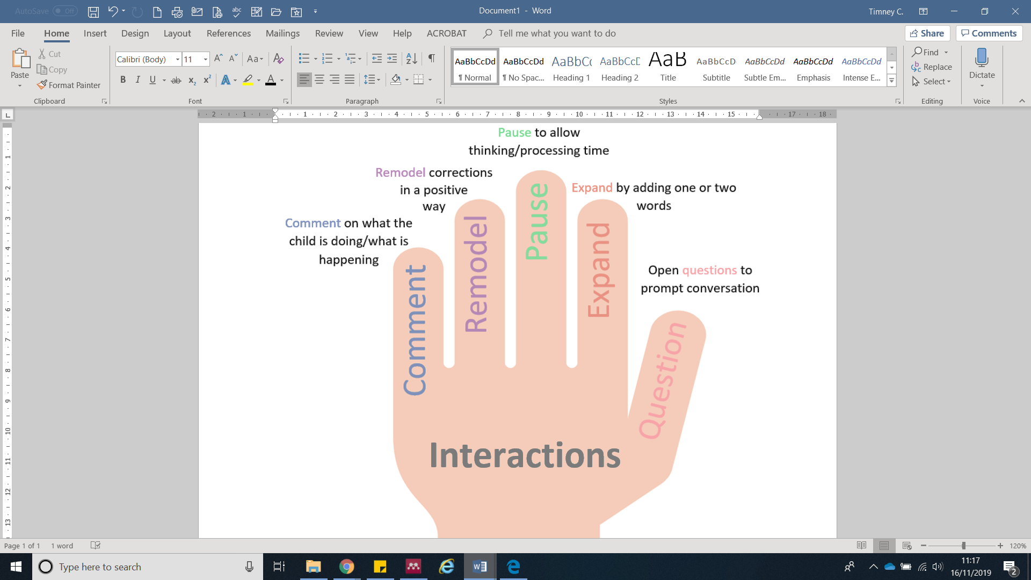

**5 key features of high-quality caregiver talk with their child.**

Adapted from: ELKLAN, 2019

Play

Play is a safe space to practise language. Children lead and adults can support. Opportunity to try out different roles and language styles. Join in with your child’s play! (Weisberg et al., 2013)

Reading

Let the child lead – book choice and pace

(Horst, Parsons & Bryan, 2011)

Interactions in reading:

* Comment on story and pictures
* Remodel throughout
* Pause, e.g. miss the end of a familiar, repetitive sentence
* Expand on the child’s comments
* Question; ask open how/why questions and turn questions into open prompts

(ICAN, 2019; LCC, 2019)

Everyday talk

* Shopping
* Housework
* Getting ready in the morning
* Evening meal

(ICAN, 2019)

Non-verbal communication

Gesture, facial expression and basic sign language can focus attention and support language development – so get animated!

(ICAN, 2019; TWMB, 2016)

Useful websites:

[ican.org.uk](http://www.ican.org.uk)

[thecommunicationtrust.org.uk](http://www.thecommunicationtrust.org.uk/)

[literacytrust.org.uk](http://www.literacytrust.org.uk)

[makaton.org](http://www.makaton.org)