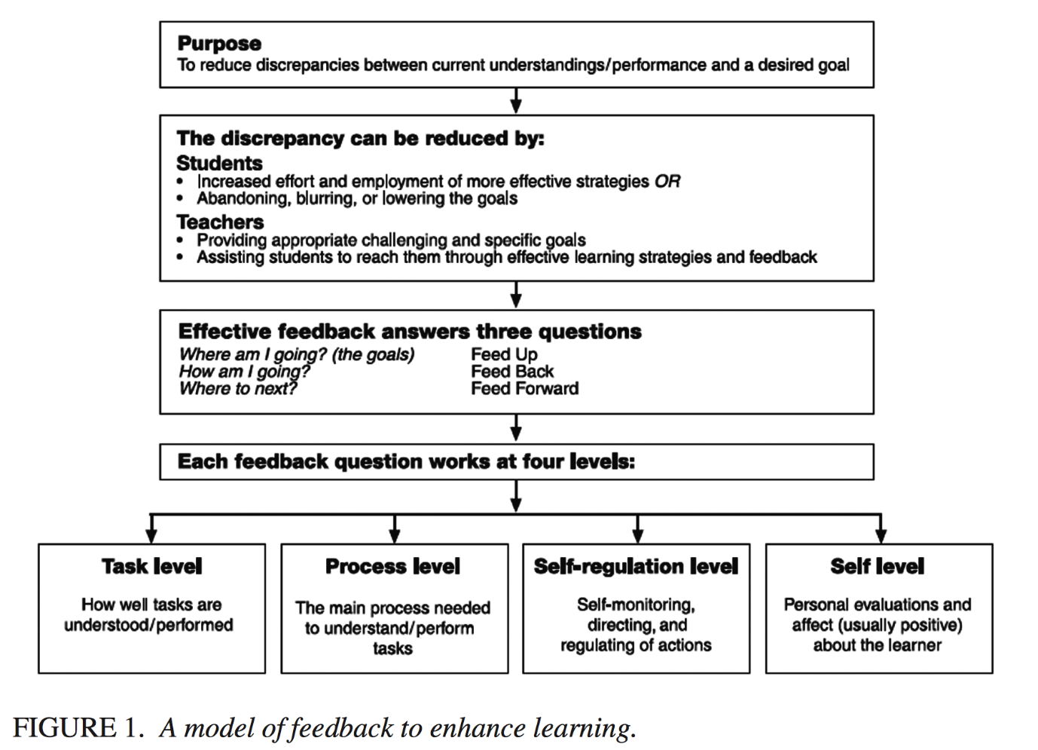

Figure 1. Four level model of feedback. Reprinted from “The power of feedback,” by J. Hattie and H. Timperley., 2007. Review of Educational Research, 77(1), 87. https://doi.org/10.3102/003465430298487
Intrinsic Motivation and Perseverance Enhanced
Adaptive Attributions
e.g. praise for process or other controllable features of performance

What performance attributions are fostered?

Maladaptive attributions
e.g. praise for easy tasks, or praise that is focussed exclusively on ability
Autonomy enhanced
e.g. praise that minimizes perceptions of external control or is endogenous

To what extent is perceived autonomy promoted?

Autonomy undermined
e.g. praise that is overjustified or controlling
Competence enhanced
e.g. praise that provides positive information about individual competence

How are competence and self-efficacy affected?

Competence undermined or only normatively enhanced
e.g. praise that conveys competence solely through social comparison
High but realistic
e.g. praise that is descriptive, to guide and regulate task engagement

What standards and expectations are conveyed?

Low or unrealistic
e.g. praise that conveys low expectations or invokes impossibly high standards
Intrinsic Motivation and Perseverance Undermined

Figure 2. Conceptual variables moderating the effects of praise on subsequent intrinsic motivation and perseverance provided that praise is perceived as sincere. Reprinted from “The effects of praise on children’s intrinsic motivation: a review in synthesis”, by J. Henderlong and M.R. Lepper., 2002. Psychological Bulletin, 128(5), 788. https://doi.org/10.1037/0033-2909.128.5.774

