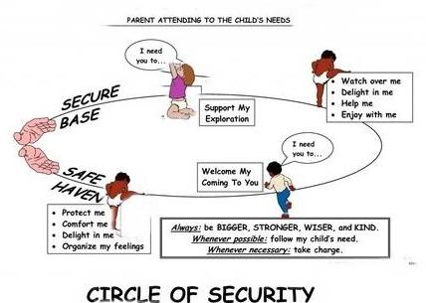
Attachment Theory Handout

What is attachment theory?
Attachment theory was developed by John Bowlby, who proposed that infants are born with a drive to survive. They do this through behaviours that seek proximity to a protective adult, such as crying or smiling. When the caregiver is consistently sensitive and responsive to the child’s attachment behaviours, an attachment is formed.
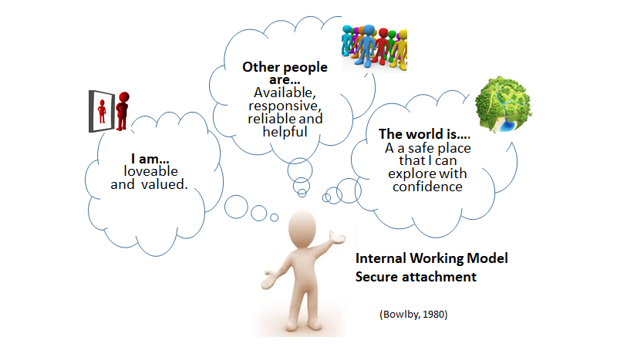
What influence does this secure attachment have on development?
It provides the child with a secure base from which they can explore and return to as a safe haven when upset, frightened or unsure. It involves the formation of an internal working model, a set of beliefs and expectations that an individual holds about themselves, others and the world around them, which influences the way in which a child will interact with others.
What is the role of attachment in early development?
The early years is the period when multiple important systems and brain areas are developing and becoming established (Gerhardt, 2014). A child’s early experiences with their caregiver influence the development of these systems.
For example, if a child starts to cry and the caregiver responds to this with acceptance, warmth and sensitivity they will likely learn and build connections in their brain that when they cry their feelings are valued. This will help them to feel confident to explore the world and eventually, manage these emotions by themselves one day.
The child also learns how to cope with stress through experiences of the caregivers being with them and helping them to calm down. This allows the child to feel safe and comfortable and builds these connections in the brain that tells them that they can rely on others in the world for help when they most need it. So attachment and relationships with caregivers helps the child to navigate the world, not only does it help them manage their emotions and stress, but being close to another person helps them to learn about their own self worth, how to interact with others and how to express their needs effectively. The encouraging message is that parents only need to get this right most of the time for their child to develop these positive brain connections (Gerhardt, 2014).
What can the adults around the child do to promote attachment?
You don’t need to have a special psychological knowledge of attachment theory to be able to support a child’s development. The key things are likely to come naturally and involve four key elements (Heale, n.d.):
- Affect Synchrony → interpreting what the child needs by how they act, and then meeting their needs through your own behaviours e.g. soothing them when they cry
- Mentalisation → understanding that your baby’s behaviour can reflect their have feelings and desires.
- Mirroring → reflecting the child’s feelings and expressions back to them. E.g. if they are smiling, we do a big exaggerated smile and laugh back to them.
- Containment → dealing with a child’s feelings and emotions to make them seem less overwhelming. Comforting them through talking and hugging helps us to show the child that we understand, and we are there to help them.
Does attachment theory influence how preschools are organised?
The key person approach is a requirement by the Department for Education (2014). A key person adopts an emotional role and is expected to be a consistent relationship for the child. Having a key person provides the child with a secure base from which they can explore and develop confidence.
Often the priority here is meeting the Department for Education’s required ratios, which is one adult to a maximum of three children under two, or four children aged two. This increases to one adult per up to thirteen children aged three or over.
Many pre-schools separate children by age, for example a room for one year olds, two year olds, and so on. In this model, a childs’ key person changes each time they move room, which could be as frequently as every year.
One alternative system is called looping. An adult is assigned as a key person to a small group of children when they join the pre-school. As the children move rooms, the adult moves with them, which provides greater consistency.
It's important to point out that building attachments at nursery doesn’t take anything away from the relationships that children already have with their primary caregivers.
Key points to remember and take away:
- Attachment can be described as a lasting psychological connectedness between human beings and is interested in how the child interacts with the caregiver and vice versa.
- Attachment experiences are an important part of the formation of the person but we need to be aware of the complexity of the term “attachment” and the dynamic and changeable nature of children's attachment with the people around them.
- We need to consider the impact of the environment on the child’s development.
- Preschool staff can use the ideas from attachment theory to consider how they group children, manage transitions and effectively use the concept of “key-adults”.

