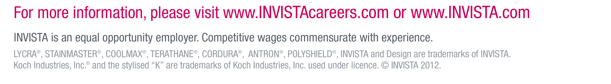

**Senior Research Scientist/Principal Engineer**

**Ref: 29237**

**Location: Wilton – Teesside/UK**

**Responsibilities**

* Provide functional leadership for fermentation development including the mentorship and development of team members
* Design and perform microbial fermentation at lab scale to produce bio-based products.
* Execute specified experiments, document experimental observations, and summarise results in technical reports
* Participate and contribute to EHS and technical meetings.

**Requirements**

* Qualified to a minimum PhD level in chemical/biochemical engineering or biological/chemical sciences
* Experience in microbial fermentation and associated analyses within an industrial biotechnology or biopharma setting.
* Excellent knowledge and understanding of microbial metabolism.
* Experience working in a multidisciplinary team including strain engineerring and systems biology.
* Competent IT skills, including Microsoft Word, Excel, and Outlook.
* Flexibility to work outside normal working hours when required
* Experience in scaling up or commissioning and troubleshooting new fermentation or bioengineering processes.
* Experience in project management or leadership
* Sound economic thinking related to production cost estimating and risk identification
* Proven leadership capability
* Experience working with commercial fermentation based Chemical Processes and product isolation would be beneficial.

**Closing Date: 16th January 2015**

Interested applicants should submit a detailed CV in English along with a covering letter indicating their salary expectations to [**humanresourceswilton@invista.com**](mailto:humanresourceswilton@invista.com)

**Please use the job title and reference code in your application.**

INVISTA seeks dynamic, high caliber scientists and engineers to join its rapidly expanding Wilton, U.K., research and development team to develop pioneering solutions to commercialise next-generation industrial biotechnology.

As part of INVISTA’s commitment to innovation, it has invested in the emerging field of industrial biotechnology, operating its own biotechnology capability out of the R&D lab in Wilton. INVISTA’s bio-scientists and engineers are working, alongside collaborators in academia and external technology companies, to develop new biotechnology processes and bring bio-derived products to market.

Through innovative research efforts at the leading edge of science, INVISTA has the potential to develop advantaged technologies that could significantly improve the cost and availability of several chemicals and raw materials that are used to produce its current products.

To work successfully in our team, candidates must be comfortable with a challenging fast paced environment where interdisciplinary team work is essential.

INVISTA is one of the world’s largest integrated producers of chemical intermediates, polymers and fibers with a portfolio of some of the world’s most recognizable brands and trademarks including LYCRA®, COOLMAX®, CORDURA®, STAINMASTER® and ANTRON®.

[Picture](http://invista.dtinet.net/govtpa/Public/CommTools/INVISTA%20Logos/Forms/AllItems.aspx?RootFolder=/govtpa/Public/CommTools/INVISTA%20Logos/INVISTA%20logo&View=%7b4066A6E0-1316-4741-852D-B3134B630F4A%7d)