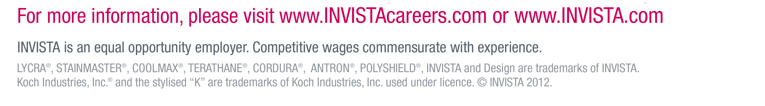

**Research Scientists – Molecular Biology/Strain Development**

**Ref: 29236**

**Location: Wilton – Teesside/UK**

**Responsibilities**

* Construction of metabolic pathways in microbial hosts for the secretion of target organic products.
* Metabolic engineering of host strains to optimize production and yield of target molecules.-
* Collaborate with the systems biology team to design optimal metabolic engineering strategies.
* Collaborate with the analytical biochemistry team to evaluate performance of engineered strains and identify bottlenecks in metabolic pathways.
* Collaborate with the protein engineering team to set in vivo performance criteria of enzymes that require optimisation.

**Requirements**

* PhD in Molecular Biology, Biochemistry, Biochemical Engineering or related discipline and experience in strain engineering.
* Proven experience with metabolic pathway engineering and knowledge of microbial physiology and genetics.
* Track record in microbial strain development/improvement using targeted and directed evolution approaches. Experience of developing novel genetic tools and genetic engineering methodologies is highly desirable.
* Excellent interpersonal and communication skills.
* Competent IT skills, including Microsoft Word, Excel, and Outlook
* Flexibility to work outside normal working hours when required.

**Closing Date: 16th January 2015**

**How to apply**

Interested applicants should submit a detailed CV in English along with a covering letter indicating their salary expectations to [**humanresourceswilton@invista.com**](mailto:humanresourceswilton@invista.com)

**Please use the job title and reference code in your application.**

INVISTA seeks dynamic, high caliber scientists and engineers to join its rapidly expanding Wilton, U.K., research and development team to develop pioneering solutions to commercialise next-generation industrial biotechnology.

As part of INVISTA’s commitment to innovation, it has invested in the emerging field of industrial biotechnology, operating its own biotechnology capability out of the R&D lab in Wilton. INVISTA’s bio-scientists and engineers are working, alongside collaborators in academia and external technology companies, to develop new biotechnology processes and bring bio-derived products to market.

Through innovative research efforts at the leading edge of science, INVISTA has the potential to develop advantaged technologies that could significantly improve the cost and availability of several chemicals and raw materials that are used to produce its current products.

To work successfully in our team, candidates must be comfortable with a challenging fast paced environment where interdisciplinary team work is essential.

INVISTA is one of the world’s largest integrated producers of chemical intermediates, polymers and fibers with a portfolio of some of the world’s most recognizable brands and trademarks including LYCRA®, COOLMAX®, CORDURA®, STAINMASTER® and ANTRON®.

[Picture](http://invista.dtinet.net/govtpa/Public/CommTools/INVISTA%20Logos/Forms/AllItems.aspx?RootFolder=/govtpa/Public/CommTools/INVISTA%20Logos/INVISTA%20logo&View=%7b4066A6E0-1316-4741-852D-B3134B630F4A%7d)